 | MINISTRY OF EDUCATION AND TRAINING

FPT UNIVERSITY
Capstone Project Document
LIB Management System
Group 4
Group Members | QUANLM – Team Leader – 60209  PHUNH – Team Member – 60177  BAOTHQ – Team Member – 60006  DIEPTN – Team Member – 60128
Supervisor | TAINT
Ext Supervisor | N/A
Capstone Project code | LIB

- Ho Chi Minh City, 02/2012 -

Table of Contents

Report No.4: Software Design Description (SDD) 3
4.1. Design Overview 3
4.2. System Architectural Design 4
4.2.1. Choice of System Architecture 4
4.2.2. Discussion of Alternative Designs 4
4.2.3. Description of System Interface 4
4.3. Component Diagram 5
4.4. Detailed Description of Components 5
4.4.1. CRC Cards (Class-Responsibility-Collaborators) 5
4.4.2. Class Diagram 7
4.4.3. Class Diagram Explanation 7
4.4.4. System Layers Overview 7
4.5. Sequence Diagram 8
4.6. User Interface Design 16
4.6.1. Description of the User Interface 16
4.7. Database Design or Data Structures 19
4.8. Other material (if any) 20

Table of Figures
Figure 1: System architecture of LIB 4
Figure 2: LIB Components Diagram 6
Figure 3: CRC Cards 8
Figure 4: Class Diagram of LIB 9
Figure 5: System Layers Overview 11
Figure 6: Search for catalogue (Basic/Detail/Advance) 12
Figure 7: Expand Rental Time of a copy 13
Figure 8: Confirm the registered order of copies 13
Figure 9: Register a copy of catalogue 14
Figure 10: Rent a copy of book 14
Figure 11: Return a copy of book 15
Figure 12: Take a registered copy of book 15
Figure 13: View a registered Information 16
Figure 14: Insert/Delete/Update an author 16
Figure 15: Insert/Delete/Update a copy of book 17
Figure 16: Insert/Delete/Update a catalogue 17
Figure 17: Insert/Delete/Update a category 17
Figure 18: Insert/Delete/Update a publisher 18
Figure 19: View Author Information 18
Figure 20: View copy of book Information 18
Figure 21: View Catalogue Information 19
Figure 22: View Category Information 19
Figure 23: View Publisher Information 19
Figure 24: Login Screen 20
Figure 25: Main Menu 20
Figure 26: Book Management 21
Figure 27: User Management 21
Figure 28: Book Rental Management 22
Figure 29: Request Management 22
Figure 30: Database design 23

Report No.4: Software Design Description (SDD)

Design Overview
The document is aimed to show the detail design of the LIB system design, from architecture design to high level design of logical.
LIB system consists of 2 parts: one is windows-form based application software, and one is a web-based application.
- Windows-form based application: is the application for the librarian to manage the information of the library and information about user and the copies of book. With the windows-form application, the user can perform most of the features of the LIB System.
- Web-based application: is the application that has been deployed to an open server for the users to connect and searching or ordering the copies of book that they want.
The architecture of LIB:

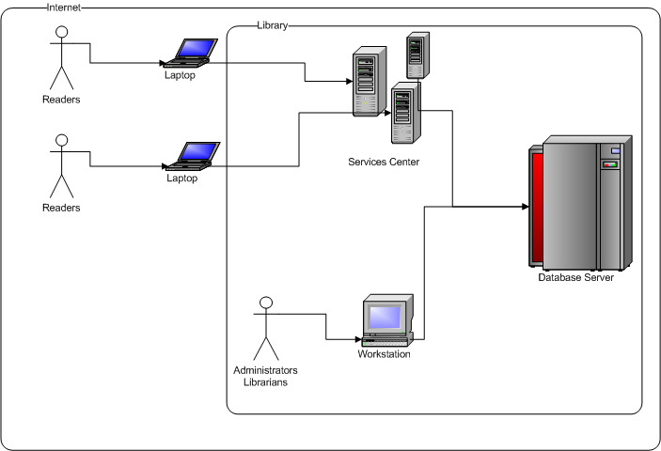
Figure 1: System architecture of LIB
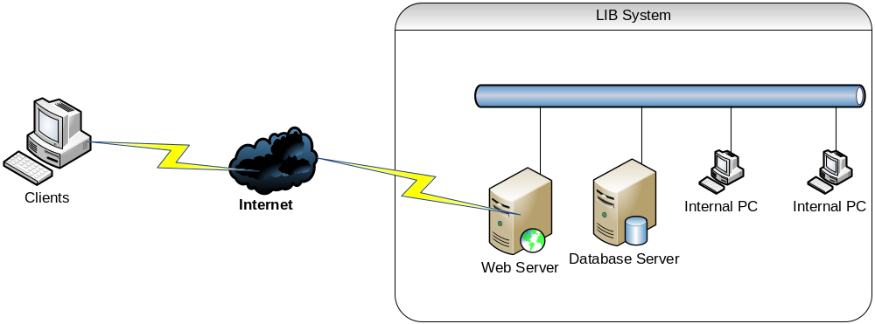
Figure 2b: Network architecture of LIB

System Architectural Design

Choice of System Architecture
Because of consisting 2 types of application in one system, the LIB system will be implemented on the type of system architecture:
- For the windows-form based application:
  - C# with .NET framework.
  - Microsoft SQL Server 2008.
- For the web-based application:
  - C# with .NET framework.
  - Microsoft SQL Server 2008.
  - Internet Information Service (IIS) 7.0

Discussion of Alternative Designs
In the alternative design of LIB system, there are 2 discussions of the system tools that had been used for developing the system:
- Microsoft Light-switch Technology: one of the Technology of Microsoft that support communication between database and application.
    - Cons: the Light-switch work at very low efficiency.
- XAMPP Server: one of the light-weight servers that has been designed for hosting application online.
    - Cons: low security.

Description of System Interface
N/A

Component Diagram
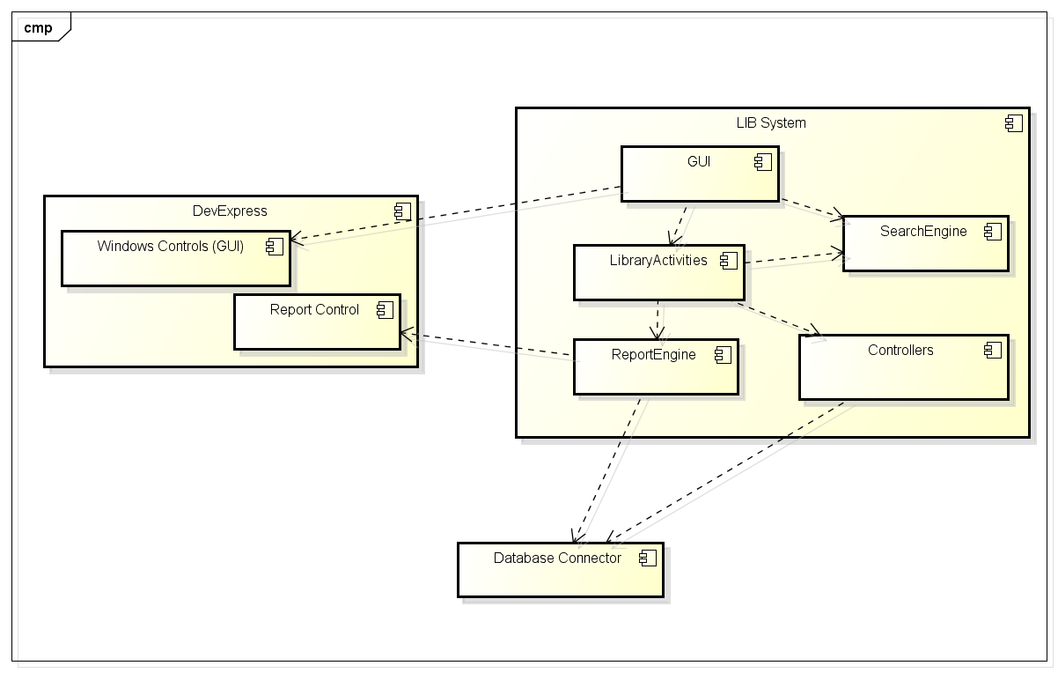
Figure 3: LIB Components Diagram

Detailed Description of Components

CRC Cards (Class-Responsibility-Collaborators)

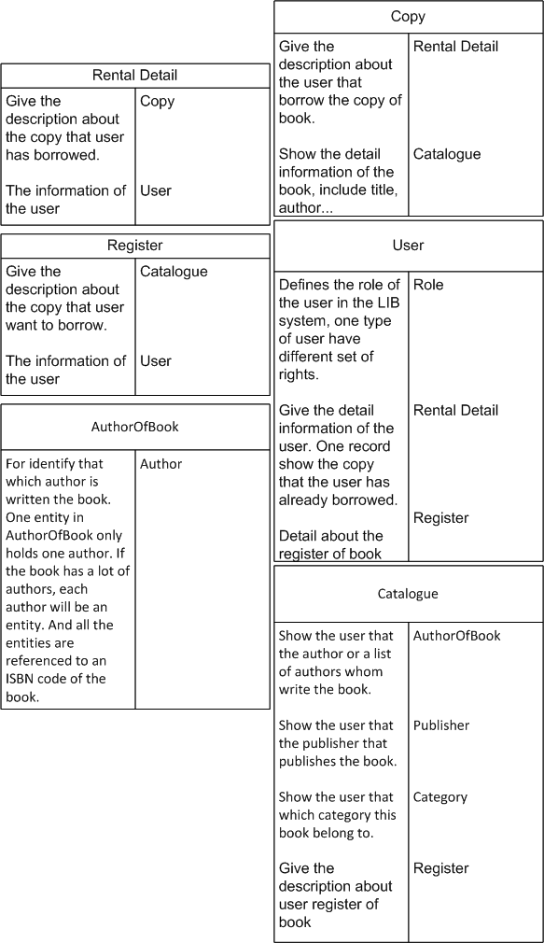
Figure 4: CRC Cards

Class Diagram
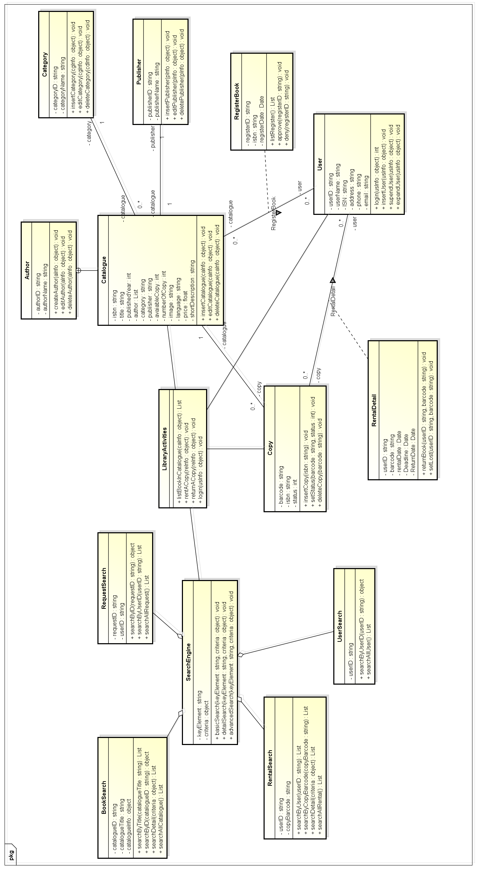
Figure 4: Class Diagram of LIB

Class Diagram Explanation
- There are 2 parts of the classes divided by class responsibility.
- In the right side are the classes that project the project master data:
  - Each Catalogue consist several Authors.
  - Each Catalogue belongs to one and only one Category.
  - Each Catalogue published by one and only one Publisher.
  - Each Catalogue consist several Copies of that title.
  - Each User can register to rent some copies of Catalogues.
  - Each User can rent some copies of Catalogues.
- The left side are the classes that represent the functionalities of the Library:
  - LibraryActivity provides the basic activities of the LIB and have relationship to Catalogue, Copy, User and SearchEngine.
  - SearchEngine provides the search abilities of LIB, contains the Book, Request, Rental and User search-ability.

System Layers Overview

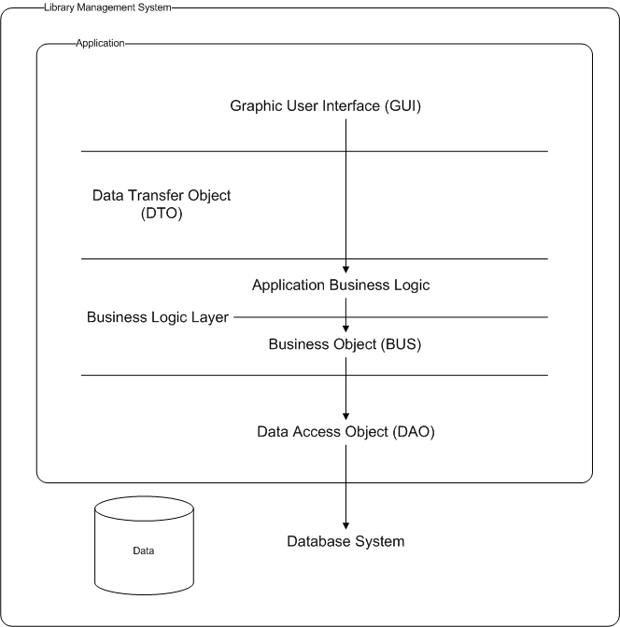
Figure 5: System Layers Overview
Name | Description
Data Transfer Object | This object for containing data which will interact with user
Business Object | Execute system business logic
Data Access Object | Directly interacting with system’s database.

System Layers Explanation
- Our system consists of an application system and a database server.
- The application system divided into 3 layers based on the functionality of object.
  - The Data Access Object (DAO) layer acts as a middle class to connect to the database server and perform the query and advance functional of database system.
  - The Business Logic Layer (BUS) is the class consist all the business functionalities of the system. In this layer, we have divide into 2 section:
    - First is the BUS, that performs the data validation and integration, including all the basic functionalities of the database system.
    - Second is the higher class, used for representing the functionalities of the LIB system, containing the business function of the LIB.
  - Data Transfer Object (DTO) projecting the database to be used as the data container for the LIB to communicate with the DB system.
- Graphic User Interface (GUI) is the interface that used to interact with the users.

Sequence Diagram

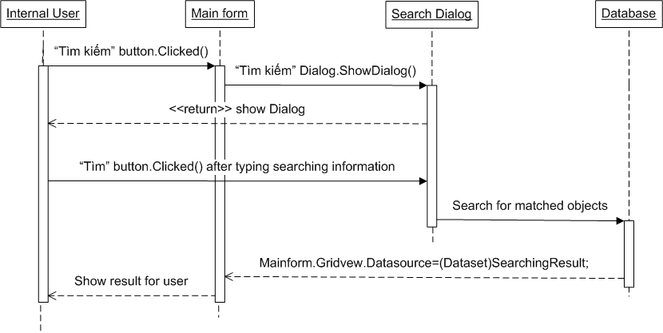
Figure 6: Search for catalogue (Basic/Detail/Advance)
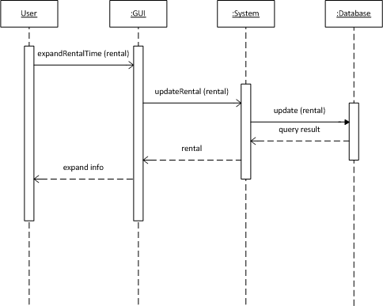
Figure 7: Expand Rental Time of a copy
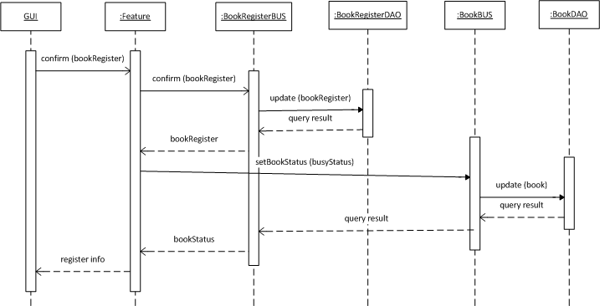
Figure 8: Confirm the registered order of copies
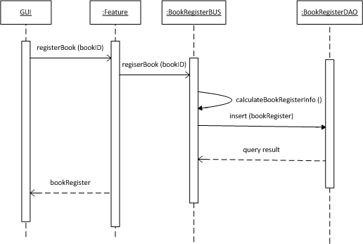
Figure 9: Register a copy of catalogue
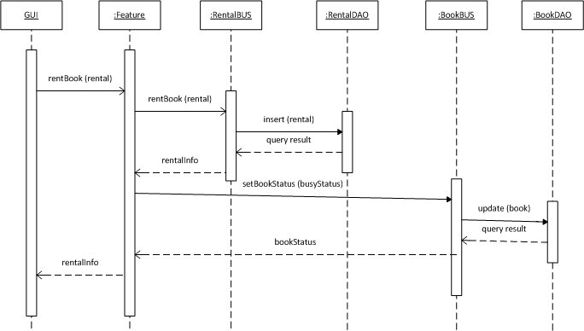
Figure 10: Rent a copy of book
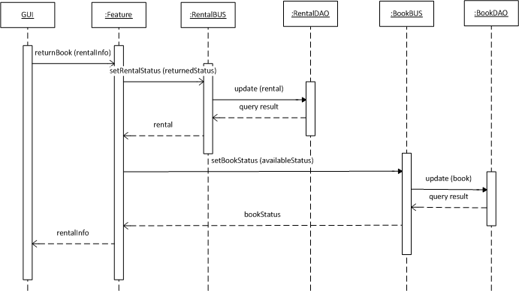
Figure 11: Return a copy of book
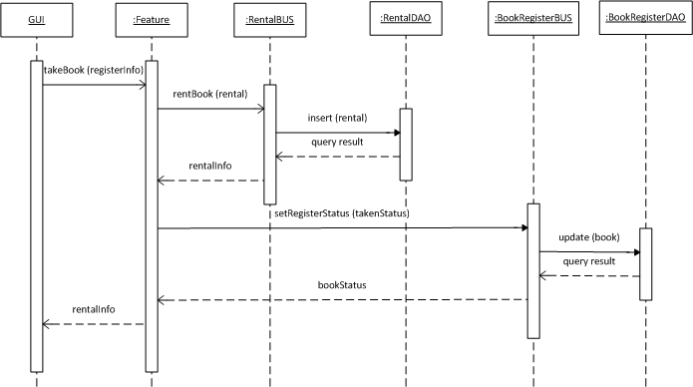
Figure 12: Take a registered copy of book
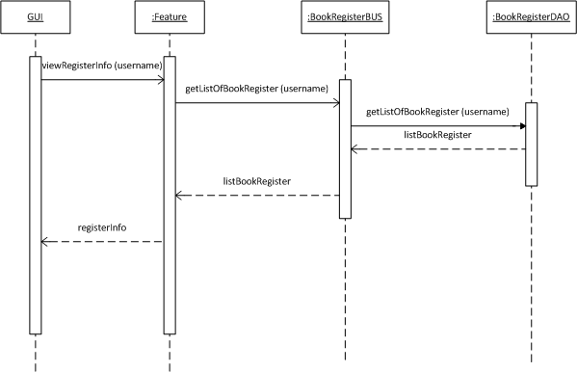
Figure 13: View a registered Information
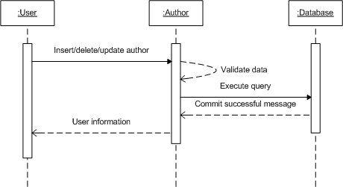
Figure 14: Insert/Delete/Update an author
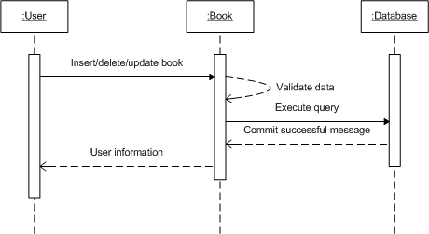
Figure 15: Insert/Delete/Update a copy of book
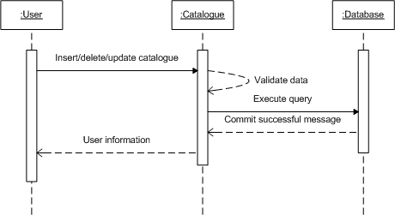
Figure 16: Insert/Delete/Update a catalogue
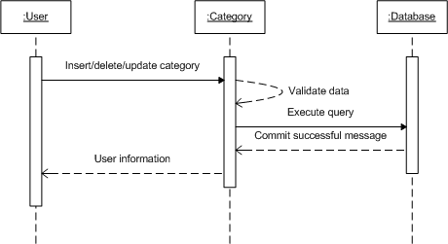
Figure 17: Insert/Delete/Update a category
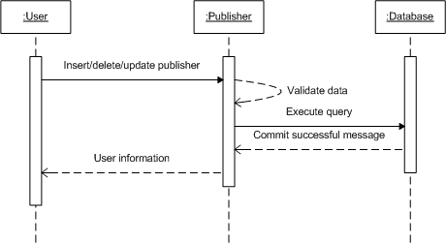
Figure 18: Insert/Delete/Update a publisher
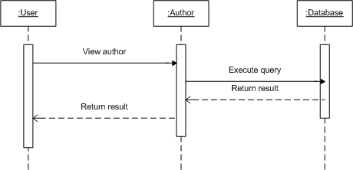
Figure 19: View Author Information
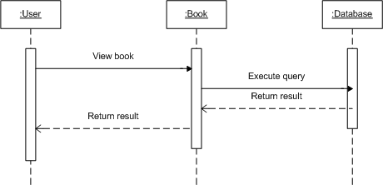
Figure 20: View copy of book Information
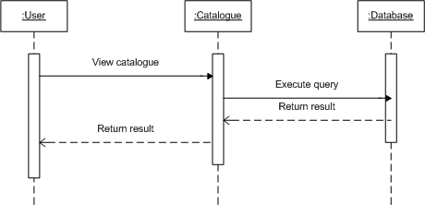
Figure 21: View Catalogue Information
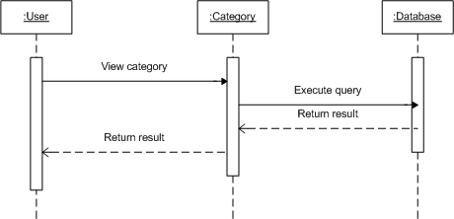
Figure 22: View Category Information
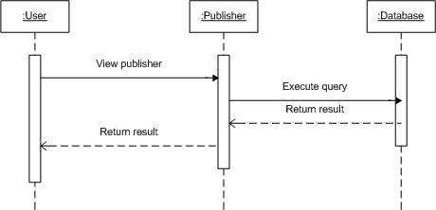
Figure 23: View Publisher Information

User Interface Design

Description of the User Interface
    - Screen Images
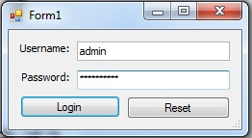
Figure 24: Login Screen

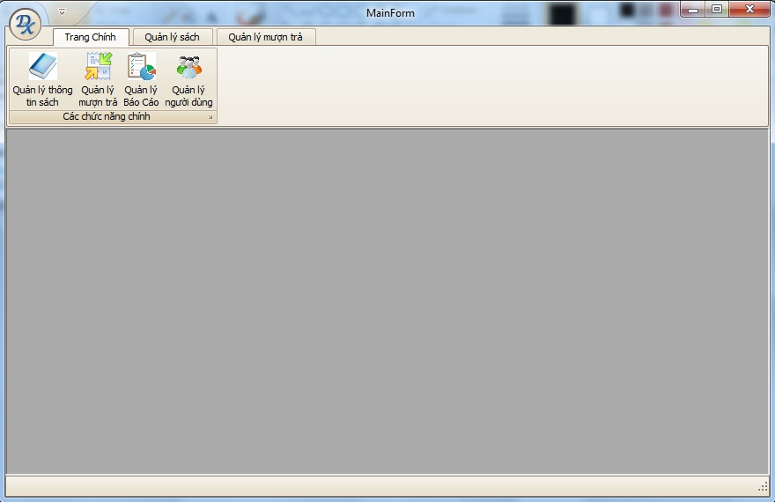
Figure 25: Main Menu

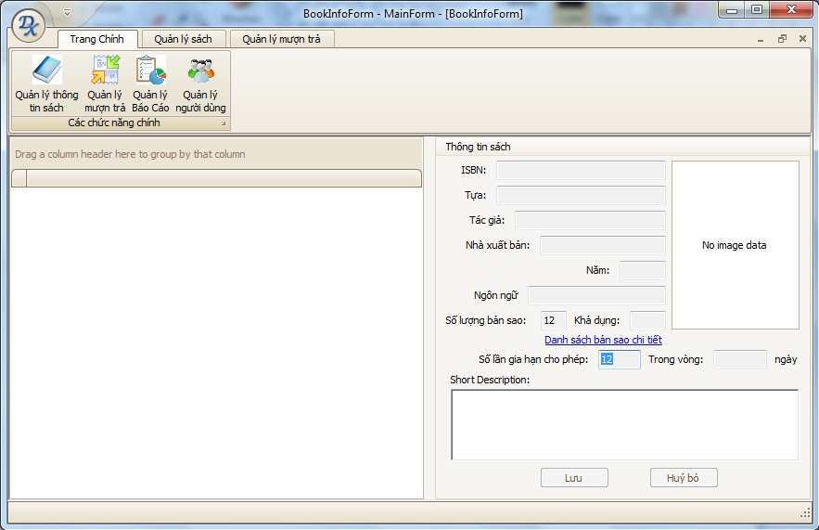
Figure 26: Book Management

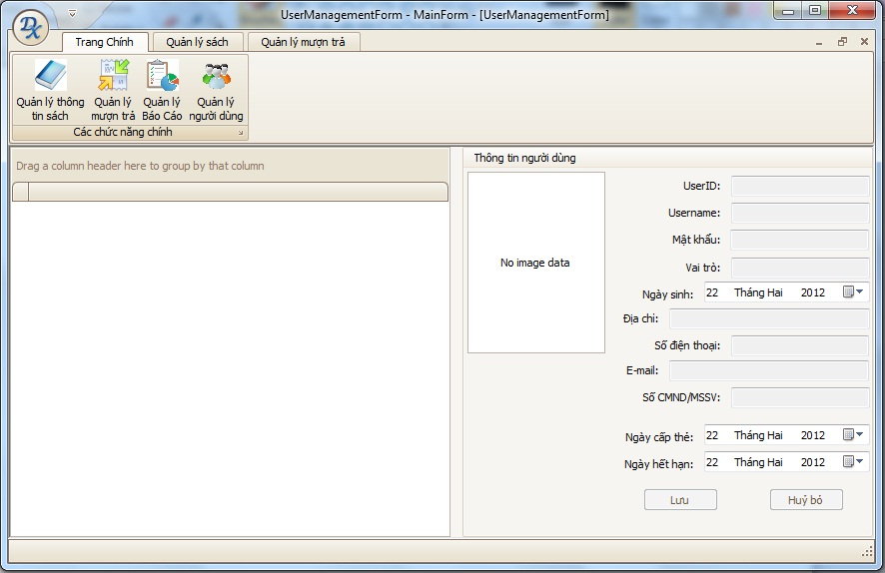
Figure 27: User Management

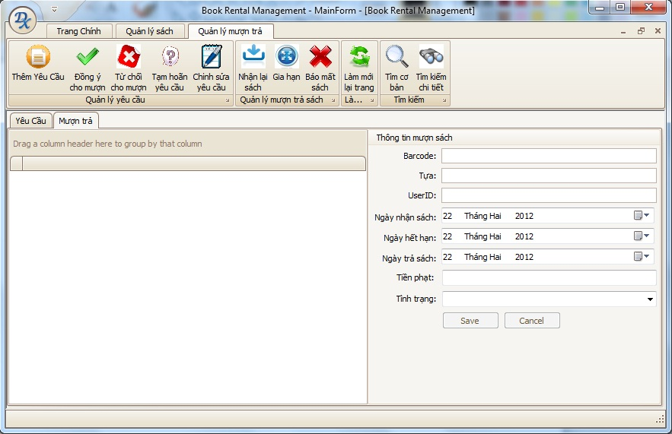
Figure 28: Book Rental Management

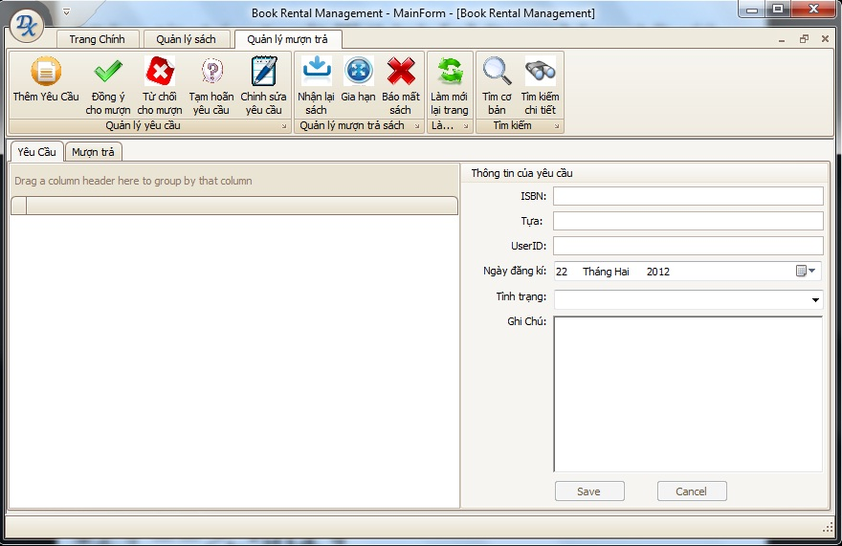
Figure 29: Request Management

    - Objects and Actions
Refer SRS

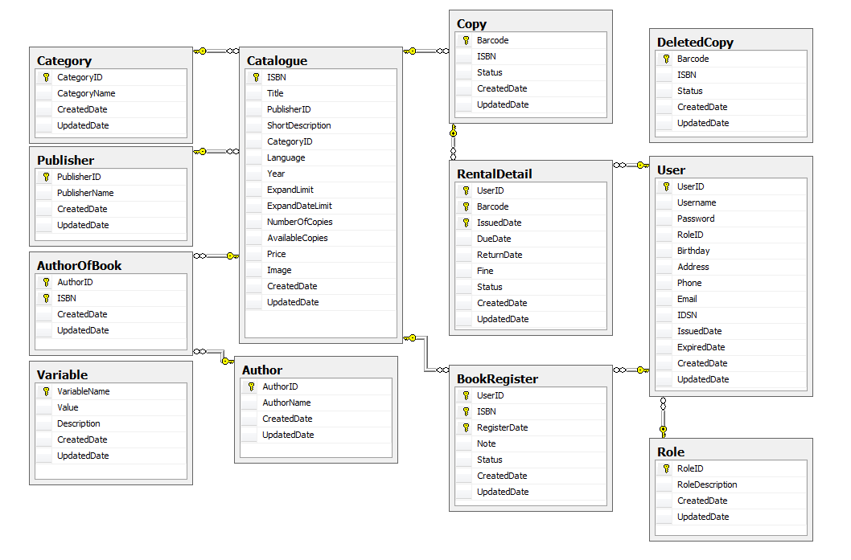
Database Design or Data Structures

Figure 30: Database design

Other material (if any)

N/A

